November 14, 2022

Jose Mari Aldeguer, President & CEO

*Thru: Ms. Boots Morales, Finance Head*

Tangent Solutions, Inc.

Philippine Stock Exchange Centre - 15/F Suite 1507-A East Tower

Exchange Rd, Ortigas Center, Pasig, Metro Manila  
  
BILLING STATEMENT

Period Covered: October 01-31, 2022

Dear Sir:  
For the period covered, this is to bill you in the amount of Nine Thousand Pesos (P9,000.00) for the following services.

|  |  |  |  |  |
| --- | --- | --- | --- | --- |
| **DATE** | **TIME** | **ACTIVITY** | **WORKED W/** | **% DONE** |
| Monday, 03 October, 2022 | 12NN-1PM | making virtualbox VMs run in the background rather than the foreground ( implementation phase ) | MSL | 85% |
| Tuesday, 04 October, 2022 | 12NN-1PM | making virtualbox VMs run in the background rather than the foreground ( implementation phase ) | MSL | 100% |
| Wednesday, 05 October, 2022 | 12NN-1PM | Disabling unnecessary user account on Windows Servers for security reason. | MSL | 100% |
| Thursday, 06 October, 2022 | 12NN-1PM | Checking dataone and vitro servers network connectivity to Rapid 7 | MSL | 100% |
| Friday, 07 October, 2022 | 6AM-7AM | Fixing Vitro-ntp, Vitro-proxy and vitro-cfe connectivity problem | MSL | 100% |
|  |  |  |  |  |
| Monday, 10 October, 2022 | 12NN-1PM | checking network connectivity issues of Wazuh and Zabbix. | MSL | 100% |
| Tuesday, 11 October, 2022 |  | Unable to remote due to some personal matter that need to attend |  |  |
| Wednesday, 12 October, 2022 | 12NN-1PM | Meeting w/ LNC, MSL and Dea for systems knowledge transfer | MSL, LNC |  |
| Thursday, 13 October, 2022 | 12NN-1PM | As requested by ControlCase, Installed nmap on ControlCase servers as well as pfsense firewalls. | MSL | 100% |
| Friday, 14 October, 2022 | 12NN-1PM | Re-connecting NOC-TACACS server to the ControlCase log collector server (Rapid7). | MSL | 100% |
|  |  |  |  |  |
| Monday, 17 October, 2022 | 12NN-1PM | Fixing NOC-RADUIS issues and checking TSI servers connection to ControlCase server (Rapid7). | MSL | 100% |
| Tuesday, 18 October, 2022 | 12NN-1PM | Fixing VITRO-POSG, VITRO-POSDB and VITRO CFE kaspersky issues. | MSL | 100% |
| Wednesday, 19 October, 2022 | 12NN-1PM | Fixing VITRO-PROXY, VITRO-NTP kaspersky issues. | MSL | 100% |
| Thursday, 20 October, 2022 | 12NN-1PM | Fixing VITRO-NMS, DATAONE-NTP kaspersky issues. | MSL | 100% |
| Friday, 21 October, 2022 | 12NN-1PM | Fixing CDD (controlcase server) login issues. | MSL | 100% |
|  |  |  |  |  |
| Monday, 24 October, 2022 | 12NN-1PM | Fixing VITRO-IDM and NOC-IDM connectivity issues. | MSL | 100% |
| Tuesday, 25 October, 2022 | 12NN-1PM | fixing sir Rico idm | MSL | 50% |
| Wednesday, 26 October, 2022 | 12NN-1PM | fixing sir. Rico idm account. | MSL | 100% |
| Thursday, 27 October, 2022 |  | Unable to remote due to some personal matter that need to attend |  |  |
| Friday, 28 October, 2022 | 12NN-1PM | NOC-Tacacs ssh re-hardening. | MSL | 100% |

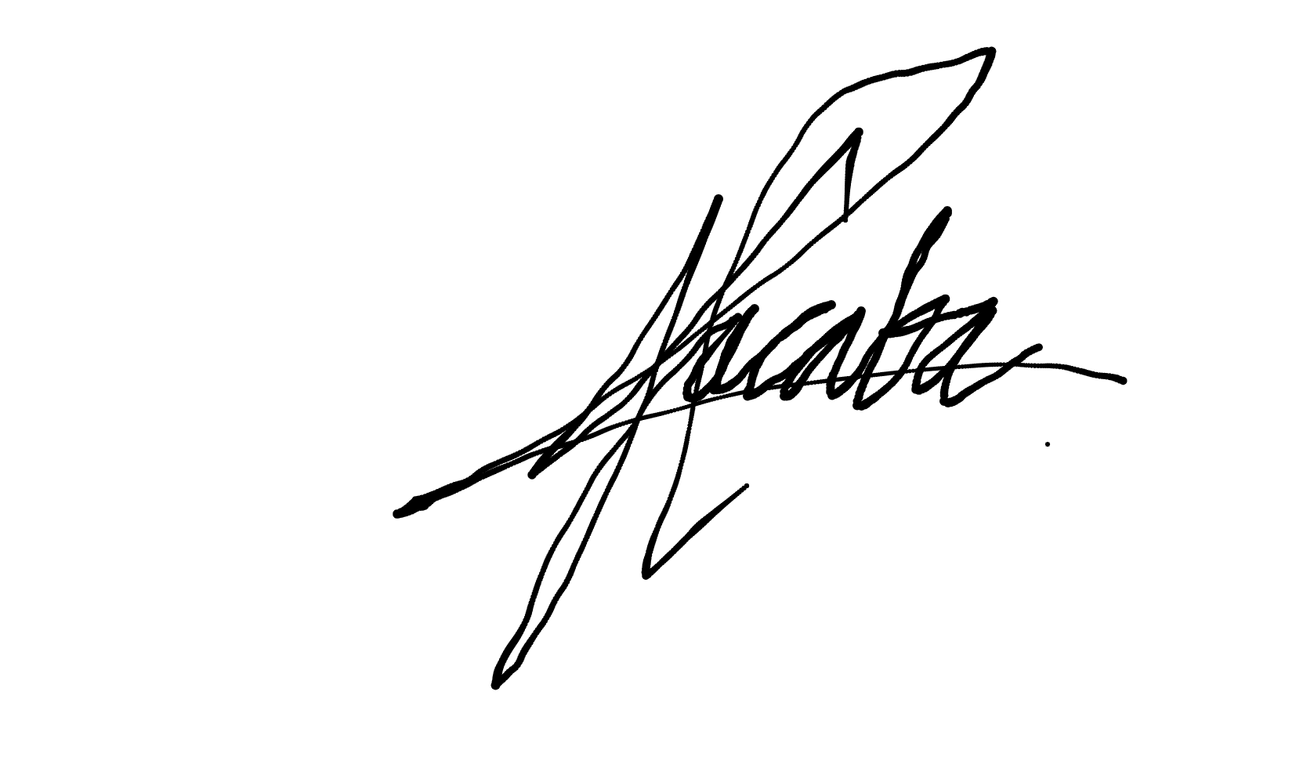

Signed:  
  
  
CARLO JAY I. JACABA

BIR TIN#: 3935894040000